AWS Accelerator Implementation:

Pre-requisites:
- Enable/Activate Control Tower in existing account.
- Increase the builds in aws code build applied value to above 5.
(Concurrently running builds for Linux/large environments).
- Create a github personal access token and store in secrets manager.
https://docs.aws.amazon.com/solutions/latest/landing-zone-accelerator-on-aws/prerequisites.html#create-a-github-personal-access-token-and-store-in-secrets-manager
- Store the personal access token in Secrets Manager as plain text. Name the secret accelerator/github-token (case sensitive).
With the AWS Management Console:
- Store a new secret, and select Other type of secrets, Plaintext.
- Paste your secret with no formatting, leading, or trailing spaces (completely remove the example text).
- Select an encryption key.
- Set the secret name to accelerator/GitHub-token (case sensitive).
- Select Disable rotation.

Check for AWSControlTowerExecution role should be attached to account level and must be in the same Organization level. It must be attached to account level.
Architecture:
Management account

Log archive/Logging account, Security account, Network Account, Shared services account!

Workload accounts
OU => Prod, UAT, Test, Dev

Considerations as below:
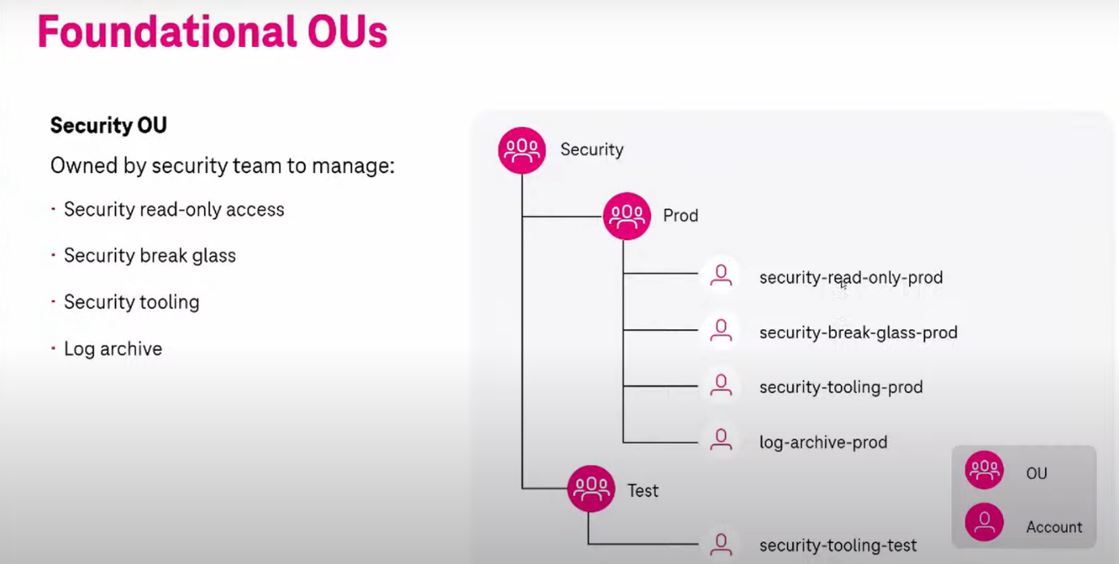
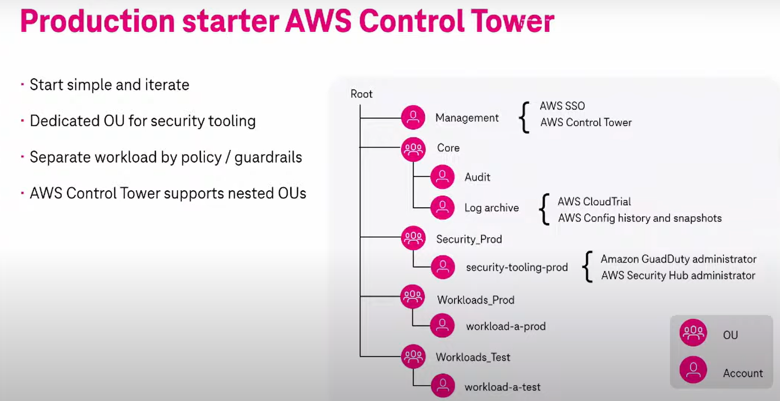
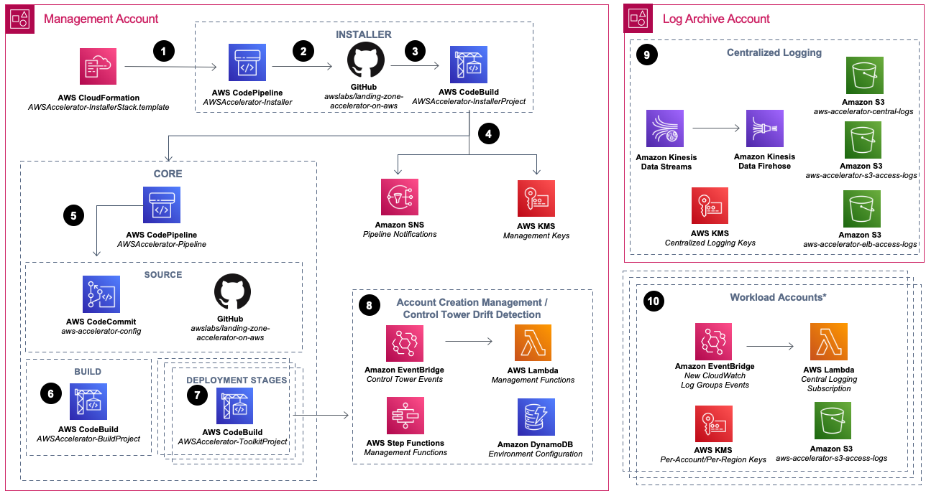
Selection of the Home Region:
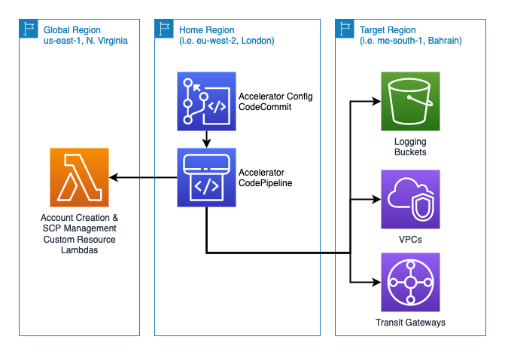
- Deploy the solution in management account.
- Setup Organizations, Log archive, Audit/security account, Security OU etc....

- Allow only desired region like (Us-east-1 and no other regions should be used – restricted)

- SCPs of maximum 5 is limitation (GMA’s requirement)

- Update the configuration file in your AWS Management account.

Opt-in Regions - Landing Zone Accelerator on AWS (amazon.com)

- Aws organizations/Control tower should be enabled in existing one.

Cloud Formation stack/template:
1. You use AWS CloudFormation to install the solution into your environment. Your environment must meet prerequisites before deploying the solution. The provided CloudFormation template deploys an AWS CodePipeline that contains the Landing Zone Accelerator on AWS installation engine.
2. The Installer pipeline (AWSAccelerator-InstallerStack) functions separately from the Core pipeline. This way, you can update to future versions of the solution with a single parameter through the AWS CloudFormation console.
3. An AWS CodeBuild project functions as an orchestration engine to build and run the solution’s AWS CDK application that deploys the Core pipeline (AWSAccelerator-PipelineStack) and its associated dependencies.
4. The solution deploys Amazon Simple Notification Service (Amazon SNS) topics that you can subscribe to for alerts on Core pipeline events, which can increase observability of your Core pipeline operations. Additionally, the solution deploys two AWS Key Management Service (AWS KMS) customer-managed keys to manage encryption at rest of Installer and Core pipeline dependencies.
5. The Core pipeline validates and synthesizes inputs and deploys additional CloudFormation stacks with AWS CDK. An AWS CodeCommit repository named aws-accelerator-config stores the configuration files that the solution uses. These configuration files are the primary mechanism for configuring and managing the solution.
6. An AWS CodeBuild project compiles and validates the solution’s AWS CDK application configuration.
7. Multiple AWS CodeBuild deployment stages deploy the resources that were defined in the solution configuration files to your multi-account environment. An optional manual review stage can be included, allowing you to view all the changes that these stages will apply.
8. The solution deploys resources that monitor AWS Control Tower lifecycle events to detect potential drift against a known good state (in other words, when the actual configuration of an infrastructure resource differs from its expected configuration). The solution also deploys resources that can automate the enrollment of new AWS accounts into your multi-account environment. When using AWS Control Tower with this solution, ensure that accounts and organizational units (OUs) within your AWS Control Tower environment are properly enrolled. You can manage this through the AWS Control Tower console.
9. The solution deploys centralized logging resources in the Log Archive account in your multiaccount environment. This includes Amazon Kinesis resources to stream and ingest logs, AWS Architecture diagram 6 Landing Zone Accelerator on AWS Implementation Guide KMS keys to facilitate encryption at rest, and Amazon Simple Storage Service (Amazon S3) buckets as log storage destinations.
10.You can enroll and provision workload accounts into your multi-account environment with additional infrastructure through the solution’s configuration files. At a minimum, new accounts are provisioned with resources that facilitate streaming Amazon CloudWatch log groups to the centralized logging infrastructure in the Log Archive account.
Note: Initial deployment includes, at a minimum, account creation, drift detection, key management, and centralized logging infrastructure. These mandatory components are part of the core feature set of the solution and are described further in Architecture details. Remaining infrastructure that the solution deploys depends on the content of the user defined configuration files.

